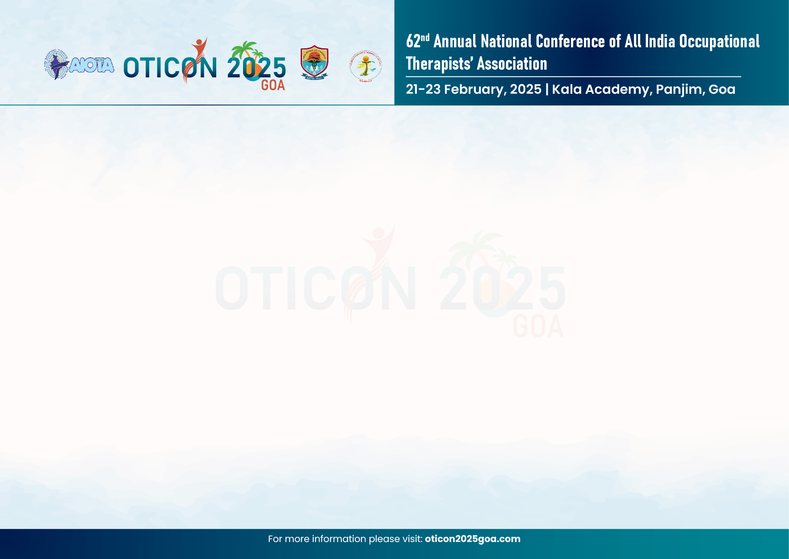

CONFIRMATION OF INSTITUTE PARTICIPATION
I hereby declare that the furnished details are true to the best of my knowledge. I confirm the participation of this Institute/ College__________________________________________________________________ in the below mentioned events.
CULTURAL EVENTS
Sr. No. | Event name | Name of contestants | Name & Contact No. of Faculty Representative | Name & Contact No. of Student Coordinator
1. | Group Dance (Max. 12)
2. | Solo Dance (Max 1)
3. | Group Singing (Max. 12)
4. | Fashion Show (Max. 10)
5. | Instrumental Musical Notes (Max. 5)
Note: Only ONE entry from each OT College in Group Dance, Solo Dance, Group Singing, Fashion Show and Instrumental Musical Notes category is permitted.
Kindly refer to the guidelines in the Cultural Programme Brochure OTICON 2025 pdf

Seal of Institute/ College Sign of HOD/ Principal

