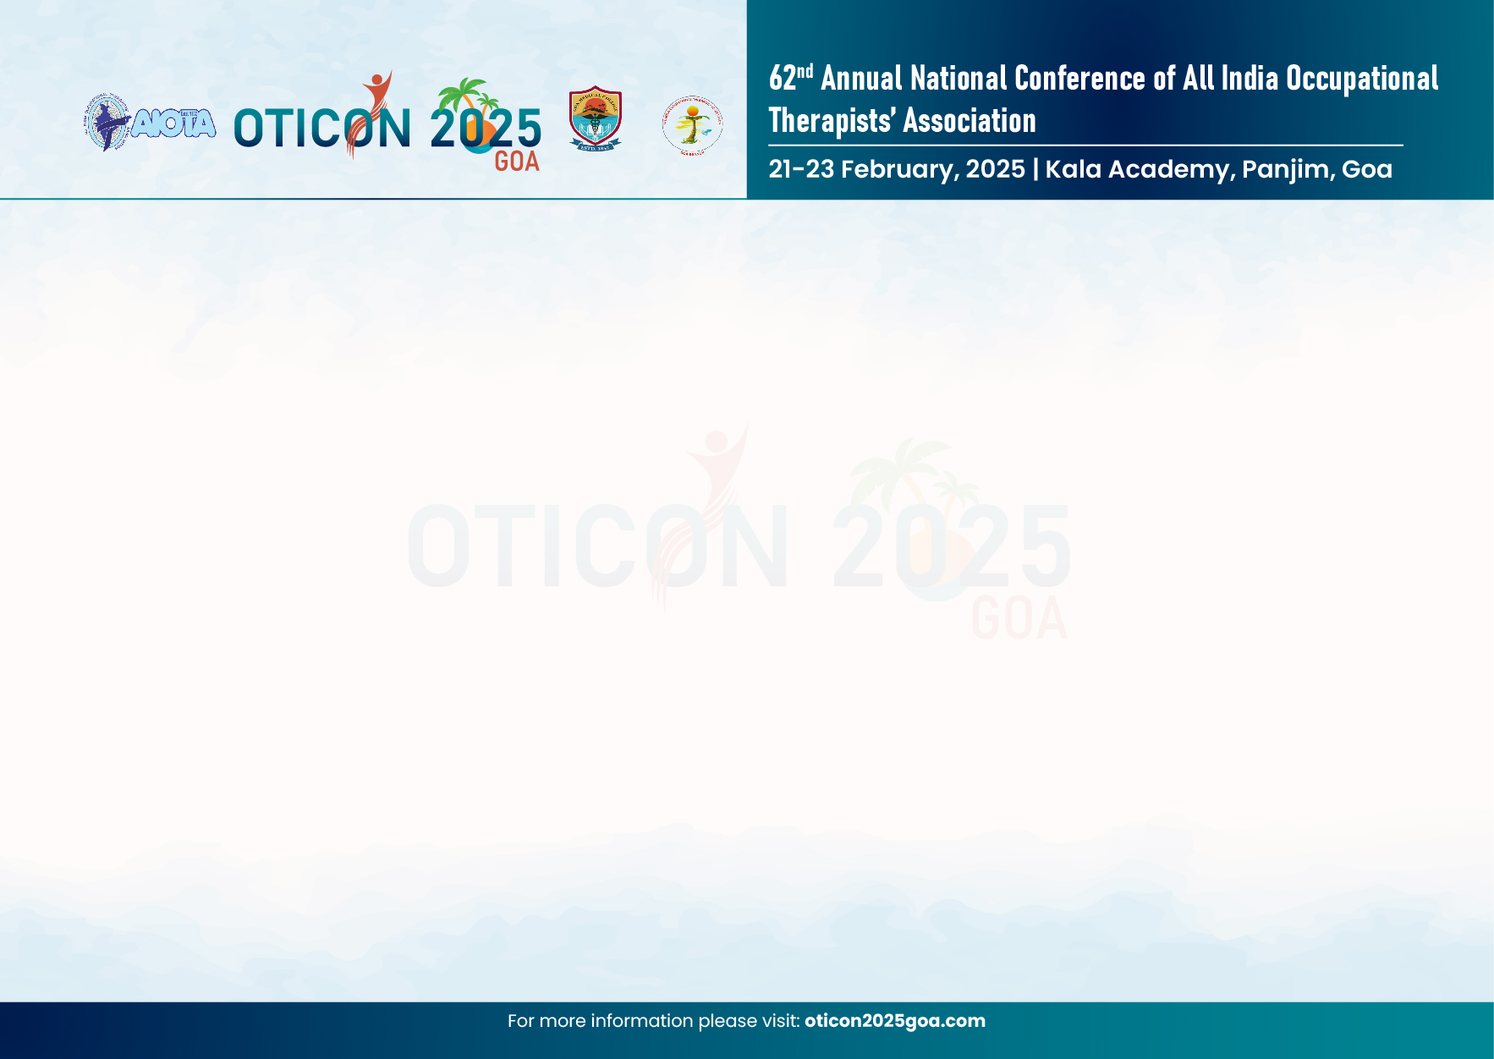

CONFIRMATION OF INSTITUTE PARTICIPATION
I hereby declare that the furnished details are true to the best of my knowledge. I confirm the participation of this Institute/ College_____________________________________________ in the below mentioned events.
SCIENTIFIC EVENTS
Sr. No. | Event name | Name of the student | Name & Contact No. of Faculty Representative | Name & Contact No. of Student Coordinator
1. | Poster Presentation
2. | Innovative Technology
3. | Street Play
4. | OMG Provo Humorous Poster
5. | Best Student Delegate Award
6. | Gold Medal Award for Best OT Graduate of 2024
Note: Only ONE entry from each OT College in Poster, Innovative Technology and Street Play category is permitted.
Kindly refer to the student guidelines in the Scientific Programme Brochure OTICON 2025 pdf

Seal of Institute/ College Sign of HOD/ Principal

